- Unity and Unreal engine 4

Reasons:
- Both are free
- Unreal engine has more languages
- Unity has more mobile and computer platform targets
- Unreal engine 4 has more desktop targets
Advantages:
- Unity is better for those people who are trying to branch their gaming expiries for multiplatform games.
- Unity has better mobile branches they can run on Windows Phone; iOS; Android; BlackBerry 10; Tizen while Unreal engine has only iOS, Android.
- Unity has more console branches too like Xbox 360; Xbox One; Wii U; PlayStation 3; PlayStation 4; PlayStation Vita; Nintendo Switch; Nintendo 3DS while unreal engine has only PlayStation 4, Xbox One, Nintendo Switch
- Unity has tv targeted games while unreal engine doesn’t like Android TV; Apple TV; Samsung Smart TV.

Unity wins vs unreal engine 4

- C# and C++

- C# is easier to learn and code.
- More rapid and potentially less errors when development than C++
- Easy to make multiple threads
- More advanced that C++

Question 2 (SE1):

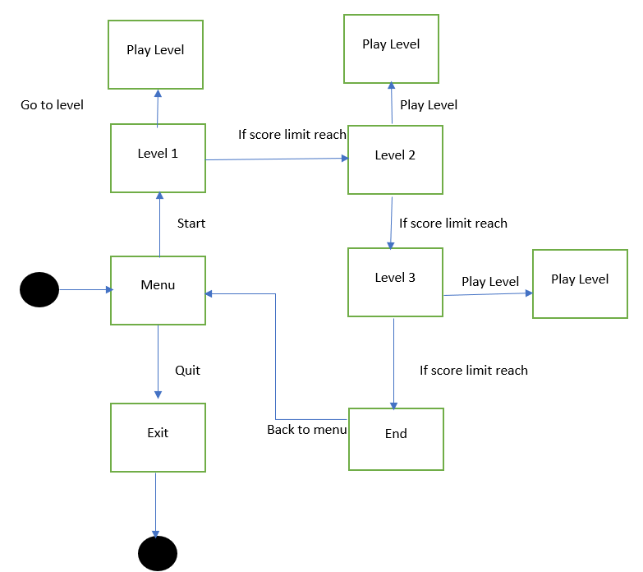

B.
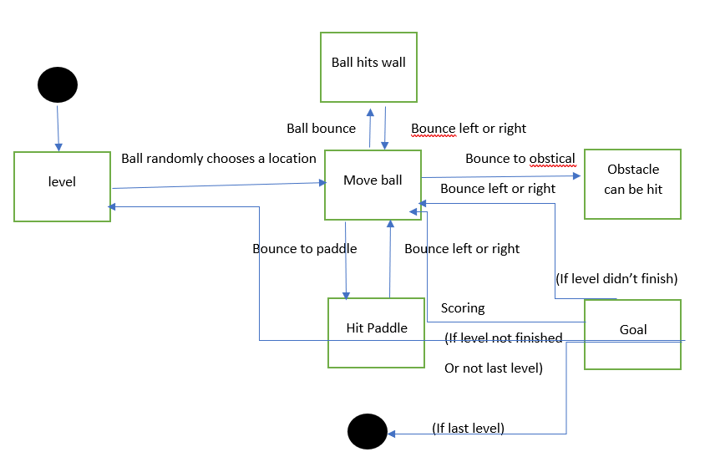

Question 3

- Compression is used to reduce file size and save disc space. For images there are 3 types of file formats that are JPEG, GIF and PNG, A lossy compression averages nearby colours and removes colour variations that are not visible by the human eye. GIF compression reduces the colour palette of an image to 256 colours, which provides an efficient way to print each colour within the image. PNG compression uses a lossless compression algorithm that filters the image data and of pixel colours based on their pixels.
- For video there are 2 common types of file formats that are MP4 and MP3, Theas file formats remove inaudible frequencies and reduce the dynamics of the sound

